Jennifer Cohan, Chairperson  Sheldon N. Sandler, Esq., Board Member  Joseph A. Pika, III, Ph.D., Board Member  Dinah M. Davis-Russ, Board Member  Lester E. Johnson, Jr., Board Member | 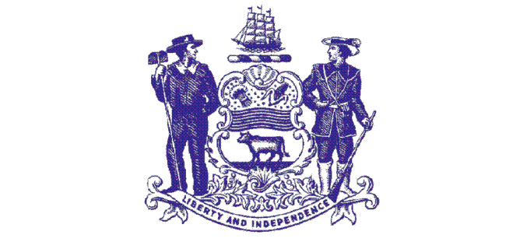 | Phone: (302) 577-5070  Fax: (302) 577-3297  merbmail@delaware.gov  https://merb.delaware.gov
State of Delaware
Merit Employee Relations Board
4th Floor, Carvel State Office Building
820 N. French Street
Wilmington, Delaware 19801

MERIT RULE APPEAL TO THE MERB

(To be used for filing appeals of all State Merit grievances EXCEPT those appealing dismissals, demotions and suspensions – Appeals must be filed within 20 calendar days of receipt of the Step 3 decision)

Name of Grievant: Click here to enter text.
Mailing Address:Click here to enter text.
Phone Number: Click here to enter text. E-mail Address: Click here to enter text.

Counsel for the Grievant (if any): Click here to enter text.
Mailing Address of Counsel: Click here to enter text.
Phone Number: Click here to enter text. E-mail Address: Click here to enter text.

Employing State Division and Agency: Click here to enter text.
Work Location and Address: Click here to enter text.

Identify the Merit Rule(s) Alleged to have been Violated: Click here to enter text.

Specific Statement of the Act or Omission complained of, including the date(s) of such act or omission:
Click here to enter text.

A brief summary of the evidence the grievant expects to present at hearing showing the appeal is timely filed pursuant to the Merit Rules and is within the jurisdiction of MERB:
Click here to enter text.

Please attach to this Appeal a copy of the written decision(s) from Step 3 of the Grievance Procedure (or the last step for which a timely answer was received if the grievance was not heard at Step 3).

Employee Signature: _______________________________________ Date: _______________________

