W. Michael Tupman, Chair  Paul R. Houck, Member  Jacqueline Jenkins, EdD, Member  Victoria D. Cairns, Member  Sheldon N. Sandler, Esq., Member |  |  | 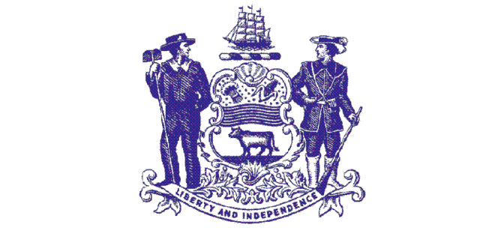 |  | Phone: (302) 577-5070  Fax: (302) 577-3297  merbmail@state.de.us  http://merb.delaware.gov
State of Delaware
Merit Employee Relations Board
4th Floor, Carvel State Office Building
820 N. French Street
Wilmington, Delaware 19801

N O T I C E

MERIT EMPLOYEE RELATIONS BOARD

Date: April 19, 2018
9:00 a.m.

Location: Delaware Public Service Commission
Silver Lake Plaza, Cannon Bldg., Suite 100
861 Silver Lake Boulevard
Dover, DE 19904
Directions: http://depsc.delaware.gov/location.shtml

AGENDA*

9:00 A.M. I. Call to order
- Hearing: Laura Rausch v. DHSS (18-01-681) Motion to Dismiss
9:30 A.M. John Mancus v. CCP (17-07-673)
- Deliberation on pending cases
IV. Review, Discussion and Possible Action on Board
Correspondence
V. Time and date and location of next meeting
VI. Public Information
VII. Adjournment

Pursuant to 29 Del. C. § 10004(e)(2), this Agenda was posted on or before March 12, 2018.

*The matters listed on the Agenda may not be considered in the order listed. Further, if it becomes clear that the hearing(s) will last all day, the Board will take an hour’s lunch period at such time during the proceedings when a break is deemed appropriate.

